Interdisciplinary Workshop
FROM WAVES TO DIFFUSION AND BEYOND
BOLOGNA, Italy: 20 December 2002

Dynamics of Mountain and Valley Winds

Dino ZARDI

Dipartimento di Ingegneria Civile e Ambientale, Universita’ di Trento

Abstract

Alpine valleys are characterized by specific boundary layer processes and typical local wind systems which deserve great interest both for their peculiar effects on valley environment and for the interaction they display with atmospheric dynamics at mesoscale and synoptic scale. A complete understanding of such processes is often a challenging goal, since the peculiar nature of single alpine valleys (location, shape, exposition to solar radiation, soil nature and covering, etc.) specifically marks the development of the above phenomena.

In recent years the Group of Atmospheric Physics at the Department of Civil and Environmental Engineering, University of Trento (Italy) has been working on measurement and analysis of atmospheric processes related to the development of thermal structures within the valley boundary layer and the occurrence of valley winds.

The nature of the phenomena under observation required the setup of a specific equipment for airborne measurements installed on a small airplane and the development of specific data analysis techniques. In particular, to obtain 3D fields of meteorological variables from airborne measurements an interpolation method based on geostatistical techniques has been introduced.

A peculiar valley wind, the so called "Ora del Garda", has been adopted as a test case. The latter occurs on fair weather days, when it starts blowing during the late morning along the northern shore of Garda Lake as a typical lake breeze and thence channels in the Sarca Valley and Lakes Valley nearby, until it finally reaches, through an elevated saddle located North of Trento, the River Adige Valley, where it appears as a strong gusty wind.

A climatological analysis of time series collected by a network of meteorological ground station located in the above valleys allowed detailed identification of many features displayed by this wind. Further understanding has been gained from specific field observations including both airborne and ground based measurements.

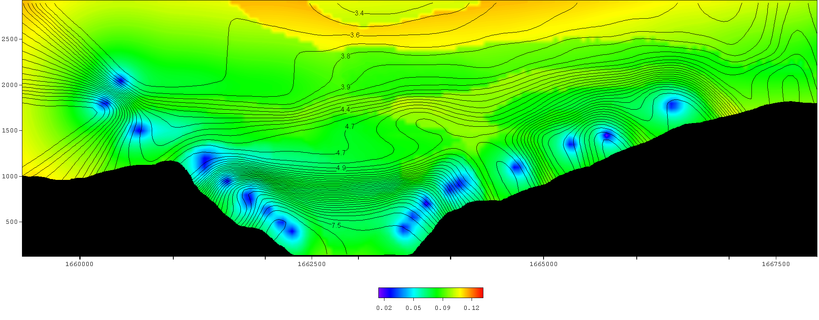

Mixing ratio [mass of water vapour (g) / mass of dry air (kg) ]in the cross section of a valley by kriging of airborne data: isolines refer to the mixing ratio and the colour field to the variance of the estimation.

